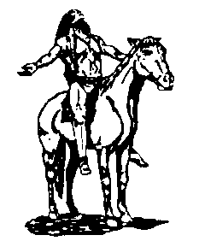
CHS CLASS OF 1959
2009 REGISTRATION FORM

Please return this form by January 15, 2009.
(Please print)

Name _____________________________________________________________________________________
(Last) (First) (Middle) (Maiden)

Home Address ______________________________________________________________________________
(Street) (City) (State) (Zip)

Home Telephone Number _( )_______________________

Cell Phone Number ( )________________________

E-mail Address __________________________________

In case we lose you, please give us the name, address and telephone number of someone who will know how to contact you:
__________________________________________________________________________________________

Fees: I will be attending: ($50.00)…………………………..…….…$_____________________

I will bring my spouse or guest: ($50.00)……………………$_____________________

Name of spouse/guest_____________________________ (Please indicate which)

I would like an extra copy of the Tom Tom: ($15.00)………$_____________________

I cannot attend but I would like a copy of the Tom Tom
mailed to me: ($20.00)……………………………………... …$_____________________

I would like to purchase yearbook advertising (or personal
message) Must be formatted and camera ready: Business card ($20.00)…….$_____________________

¼ page ($25.00) ……….…$_____________________

½ page ($50.00) ………….$_____________________

full page ($100.00)…………$_____________________

I would like to make a contribution:……………………………$_____________________
(Any amount will be appreciated!)
TOTAL: ………….$_____________________

Please mark one: Check is enclosed_______ I will send my check by March 15th _______

Please make your check payable to: Tulsa Central Class of 1959 and mail it with this form to

Mrs. Maggie (Margaret Will) Cornell
2926 East 75th Court
Tulsa, OK 74136-5640

Questions? Contact Karen Anderson Hughes at karenahughes@cox.net or (918) 627-4086 or (918) 636-8150

